Wumpus World Simulator Version 0.0

The functionality is very basic right now. The GUI is created using the help of the SFML library for C++.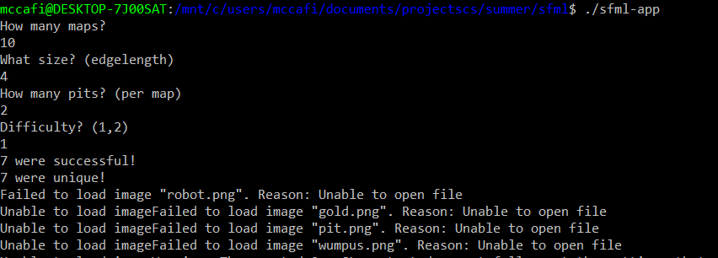

Above you can see the terminal input, reminiscent of the original project. This is from the “stable” release I kept which is definitely bug free, which is why it only has the simple 2 difficulty levels. The “beta” release, which is relatively stable but not fully tested, has the 3 difficulty levels as well as the shoot vs not shoot Wumpus setting.

What is new, obviously, are the “Failed to load” warnings. This is because I have not net drawn images for the robot, gold, pit, and Wumpus. Right now, I am using color codes instead (blue for robot, yellow for gold, black for bit, and green for Wumpus).

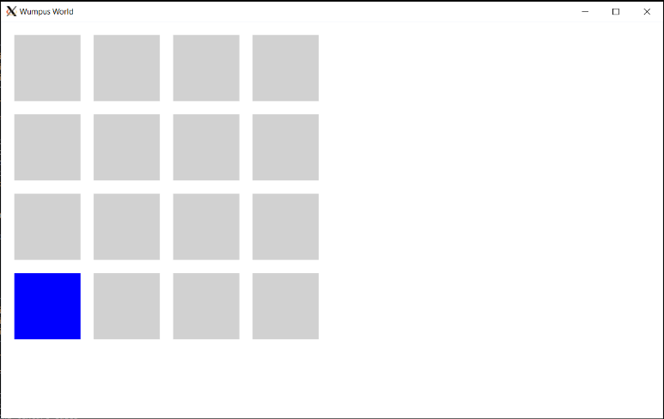

Above you can see what it looks like when you start the program. It is pretty basic. The blue square represents the robot.

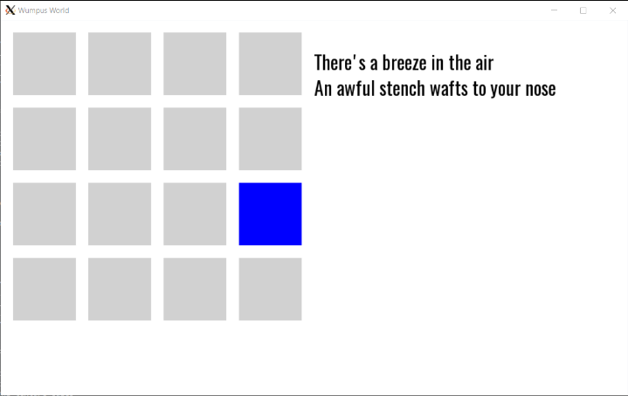

Above you can see what the hints look like. They will be prettier in the future.

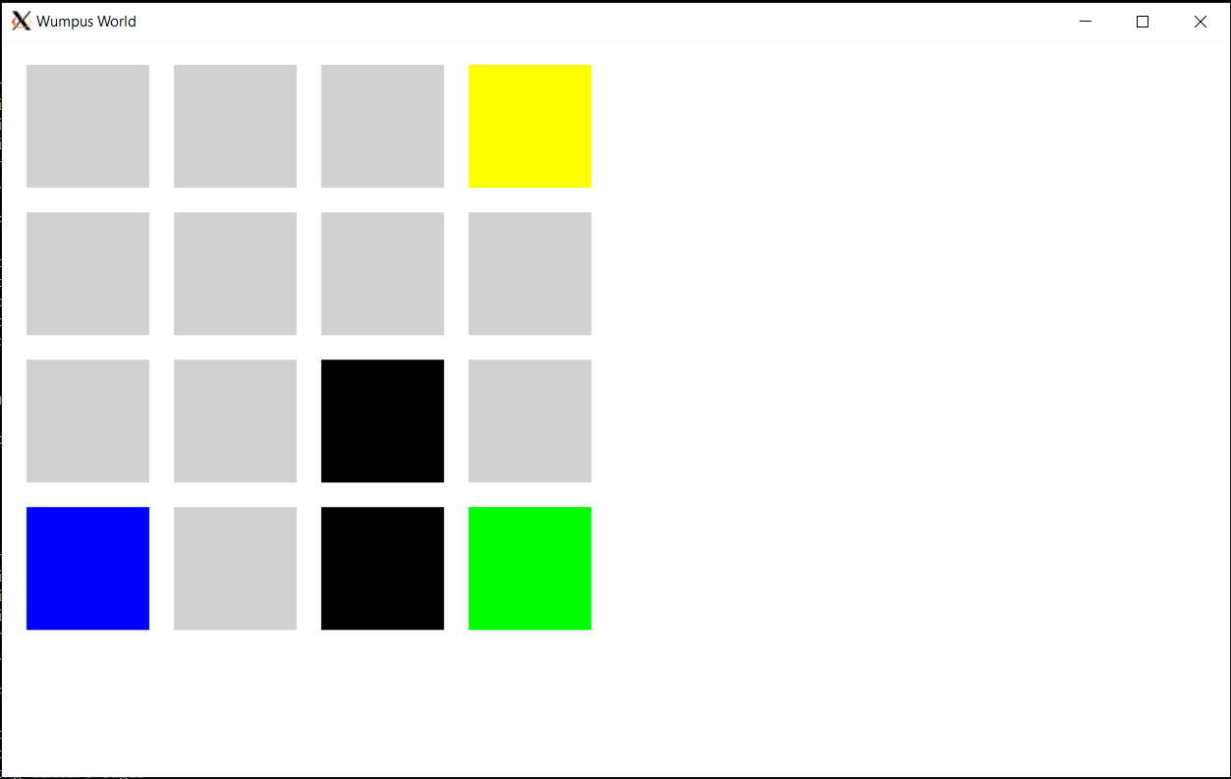

Above is the “xray vision” mode. All of the obstacles’ locations are revealed. This mode is meant to assist students in realizing what they did wrong when their strategy fails. It will also help me debug if I mess something up!